College of Engineering

Emergency Door Sign Information FY16

Building/Room number: N386

Department: Electrical and Computer Engineering

Laboratory Hazards: ***Circle*** Pictograms that represent chemical hazards in your laboratory.

[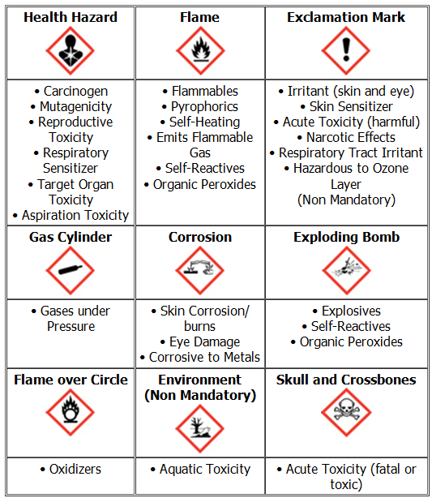](http://www.google.com/url?sa=i&rct=j&q=&esrc=s&source=images&cd=&cad=rja&uact=8&ved=0ahUKEwjZ5bDUzvLKAhUJeCYKHY3yB9QQjRwIBw&url=http://www.vaoshalawnews.com/2013/02/12/the-osha-global-harmonized-system-for-hazard-communication/&psig=AFQjCNENYmJ7rlg-HIgeNq4_ctQeiuYxAw&ust=1455379861561429)

***Circle*** all that apply: Radioactive material, X- Ray, Laser, Biological (Biosafety Level 1 or 2)

PPE Requirements, ***Circle*** all that apply: lab coat, tyvek, eye protection, gloves, dust mask,

respirator, hearing protection, hard hat

**Emergency Contact Information: MUST BE A CELL NUMBER**

Principal Investigator: Name/Number Aaron T. Becker (217) 722-2058

Lab Staff: Name/Number Li Huang (713) 497-9818

Department Safety Coordinator: Name/Number________________________________________________________________